Athaillah Adhar Jumana – 2502008246
Darryl Maximillian Bastaman Limas – 2501992513
Theophilus Deoxyrheinhart – 2501969012
Samuel Kusuma - 2540130112

Soal
Case
Jee Keyboard Store
Jee Keyboard Store is a keyboard shop specialized on selling modern keyboard that able to increase people productivity while typing. However, Jee Keyboard Store is still a new store that has just opened, and only provides four types of keyboards, which are shown below:
Name | Image File | Price | Stock | Description
Igoltech Keebs XO200 | keyboard1.png | 800000 | 56 | Classic black and yellow combination with modern architecture.
Dark Black RGB | keyboard2.png | 1500000 | 116 | RGB LED has come to this futuristic keyboard with elegant style.
Watermelon Keebs Z200 | keyboard3.png | 750000 | 9 | Did you ever seen watermelon in keyboard? Now you see!
Igoltech Classic Keebs | keyboard4.png | 1250000 | 56 | Business keyboard with modern design make your style cool.
Because unDerPale is still newly opened store, they just start selling the products with some item for each product. But their boss wants to sell more and more overtime. That is why they hire you as a programmer to make an application for handling user’s transaction using Java Programming.

- Login Window
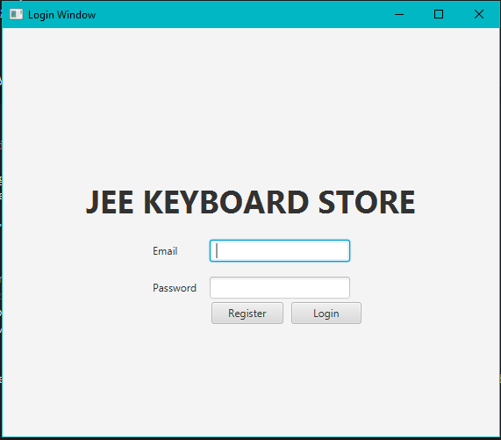
Figure 1. Login Window
The application will display a Login Window with the following components:
- Label for the email and password.
- TextField to input the email.
- PasswordField to input the password.
- Button for the login button, and register button.
  - Login button. The application will validate the form based on following requirements:
    - Validate email must be filled.
    - Validate password must be filled.
    - Validate credential (email & password) that user input is correct
    - Redirect to window based on the user signed. If email is ‘admin’ and password is ‘admin’, then redirect to Admin Window. If another credential, then redirect to User Window.
  - Register button. The application will close the Login Window and open the Register Window.
- Every error message, must using Alert, as shown below
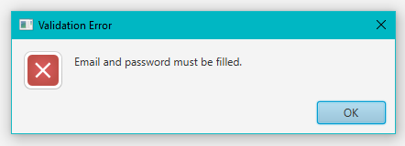
Figure 2. Alert

- Register Window
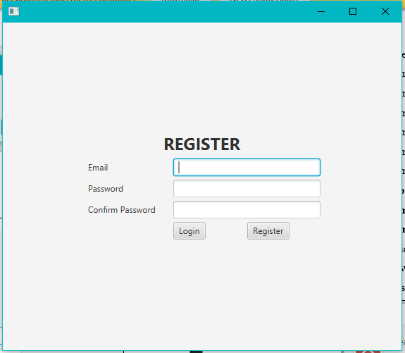
Figure 3. Register Window
The application will display a Register Window for register new user data with the following components:
- Label for the email, password, and confirm password.
- TextField to input the email.
- PasswordField to input the password and confirm password.
- Button for reset button, login button, and register button.
The description for this window are listed below:
  - Login button. The application will close the Register Window and open the Login Window.
  - Register button. The application will validate the form based on following requirements:
    - Validate email must be filled.
    - Validate email must ends with ‘@email.com’.
    - Validate email must have only one ‘@’.
    - Validate email must not have space.
    - Validate email must not starts with ‘@’.
    - Validate email must be unique, have not used for any registration before.
    - Validate password must be filled.
    - Validate confirm password must be filled.
    - Validate confirm password must be matched with the password.
    - After all validation succeed, the application will save the data in the system, close the Register Window, and open the Login Window.
- Every error message, must using Alert, as shown below
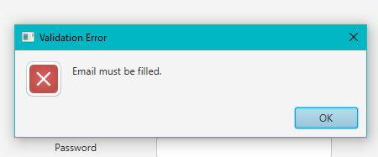
Figure 4. Alert

- Manage Keyboard Window
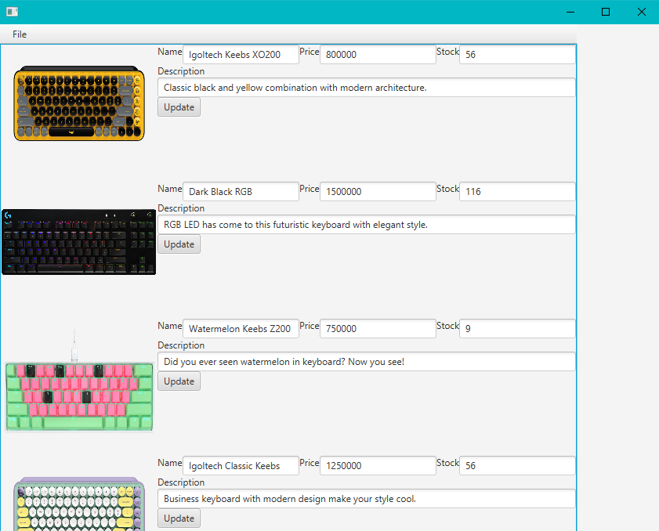
Figure 5. Manage Keyboard Window
The application will display the Manage Keyboard Window for the admin to update the keyboard’s price, keyboard’s stock, and keyboard’s description. The list of component are listed below:
- Label for the keyboard name, keyboard price, keyboard stock, and keyboard description.
- TextField to keyboard name (must be disabled), keyboard price, keyboard stock, keyboard description.
- Button for update item button.
- ImageView for display image.
- MenuBar for navigation bar. Included Menu and MenuItem, as the shown below:
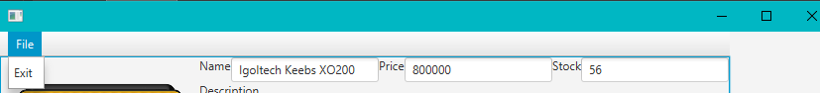
Figure 6. Navigation Menu
The description for this window are listed below:
- Display the images for each item using ImageView.
- Display all of the current keyboard’s name, price, stock, and description when the Manage Keyboard Window is opened.
- If the user clicks the update item button, the application will:
  - Validate stock must not empty.
  - Validate price must not empty.
  - Validate stock must numeric.
  - Validate price must numeric.
  - Validate stock must more than or equal to 0.
  - Validate price must more than 0.
  - Validate keyboard’s description must not empty.
  - After all validation succeed, the application will update the item data.
- If the user clicks the image, the application will open the View Image Window to show the selected item image.
- If the user clicks the logout menu, the application will close the Manage Keyboard Window and open the Login Window.
- Every error message, must using Alert, as shown below
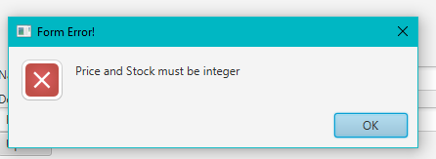
Figure 7. Alert

- View Image Window
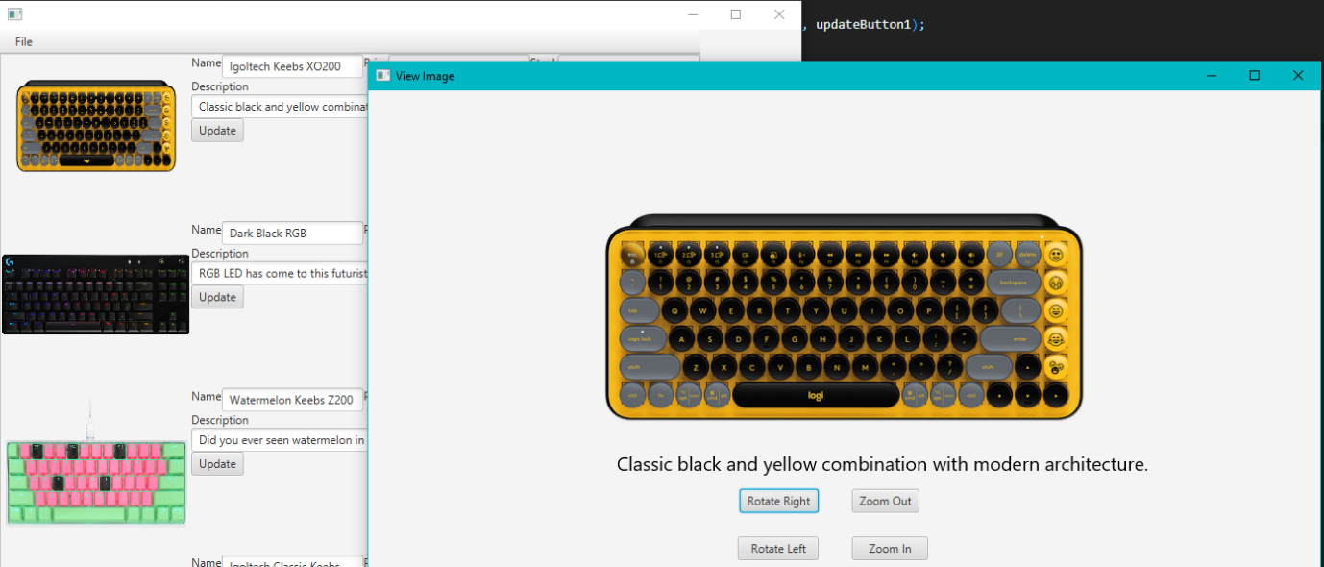
Figure 8. View Image Window
The application will display the View Image Window when admin clicked keyboard image button from Manage Keyboard Window. The list of components are listed below:
- Button for rotate left button, rotate right button, zoom in button, zoom out button.
- ImageView to show image.
- Text to show description.
The description for this window are listed below:
- Display the image of the keyboard depends on what image clicked from Manage Keyboard Window.
- Display the keyboard description based on the keyboard image that was clicked before.
- If the user clicks the rotate left button, the image will be rotated left to -90 degrees.
- If the user clicks the rotate right button, the image will be rotated right to 90 degrees.
- If the user clicks the zoom in button, the image will be zoomed in to 1.2 times larger from its last scale and validate image scale x does not exceed 2.5.
- If the user clicks the zoom out button, the image will be zoomed out to 0.8 times smaller than its last scale and validate image scale x does not less than 0.4.

- User Window
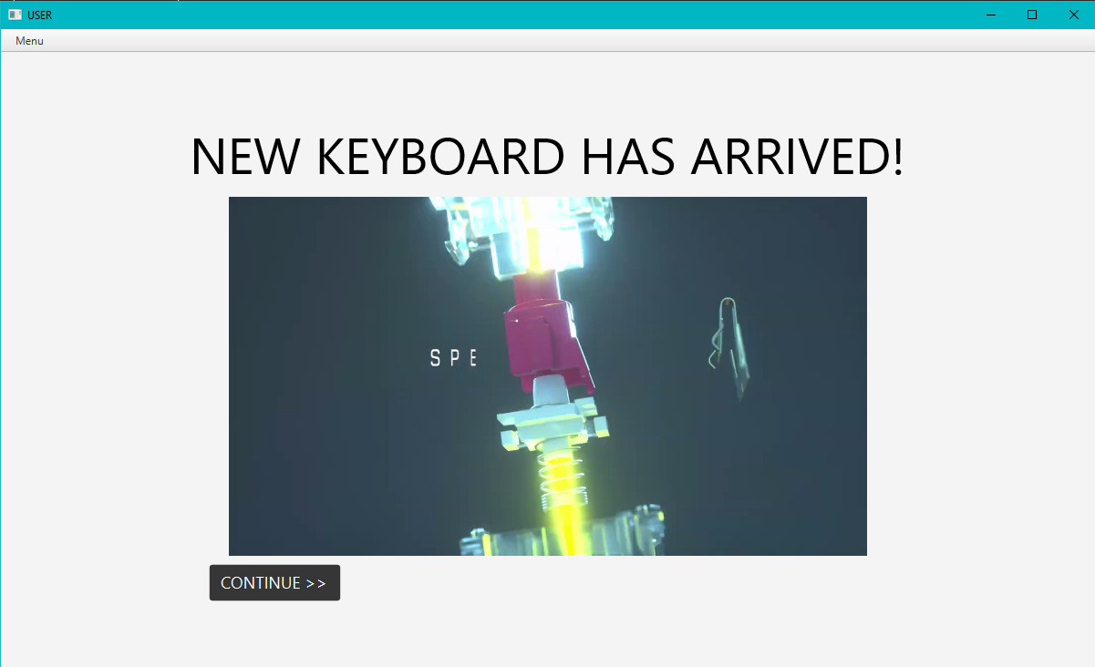
Figure 9. New Keyboard Scene
The application will display the User Window when users log in from Login Window, which shows New Keyboard scene at first. The list of components is listed below:
- Text for the title.
- MediaPlayer for the video.
- Button for the continue button.
- MenuBar for navigation bar. Included Menu and MenuItem, as the shown below:
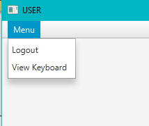
The description for this window are listed below:
- Every user scene has the Menu Bar.
- Video to display promotional video using keyboard.mp4 in the assets folder. The video must be repeated after the video ends.
- If users clicked Continue button or View Keyboard menu, then the scene changed to Catalogue and Cart scene.

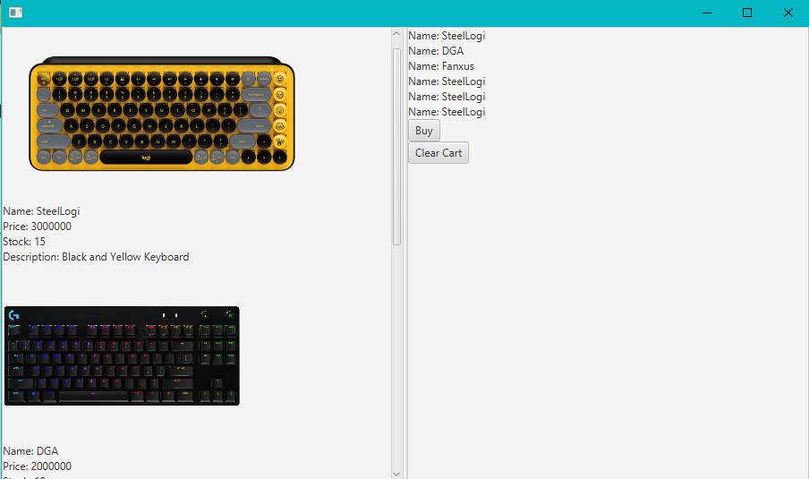
Figure 10. Catalogue and Cart Scene
The application will change scene to Catalogue and Cart when users clicked Continue button from New Keyboard or View Keyboard menu. The list of components are listed below:
- Text for the keyboard name, keyboard price, keyboard stock, and keyboard description.
- Button for buy button, clear cart button.
- ImageView for display keyboard image.
- MediaPlayer for play LoFi music.
The description for this window are listed below:
- Display the logged on user’s cart. The user’s cart is saved in the system, so when the user re-login, the user will have the same cart.
- Display the images for each item using Image View
- Display the keyboard’s name, keyboard’s price, keyboard’s stock, keyboard’s description based on the item list in the system.
- Play the audio using lofi.mp3 music in the assets folder while users are on Catalogue and Cart scene.
- Every image on list keyboard has the following effect when dragged by mouse:
    - If the user drags an item inside the cart, then:
      - Validate if the item’s stock must be greater than 0. Otherwise, the item cannot be added to the cart. For example, if the item’s stock is 4 and the user already put 4 items to the card, the user cannot Add the item to the cart.
    - If the item has stock, the application will:
      - Add the item to the user’s cart (add 1 quantity every drag and drop) and save it to the system.
- If the user clicks the Clear cart button, the application will delete all user’s cart.
- If the user clicks the Buy button, the application will:
    - After all validation is successful, reduce the item’s stock based on the item in the user’s cart and clear the user’s cart.
- If the user clicks the image, the application will open the Item Detail Window to show the image and description of the clicked item.
- If the user clicks the logout menu, the application will close the User Window and open the Login Window.
- Every error message, must using Alert, as shown below

- Item Detail Window
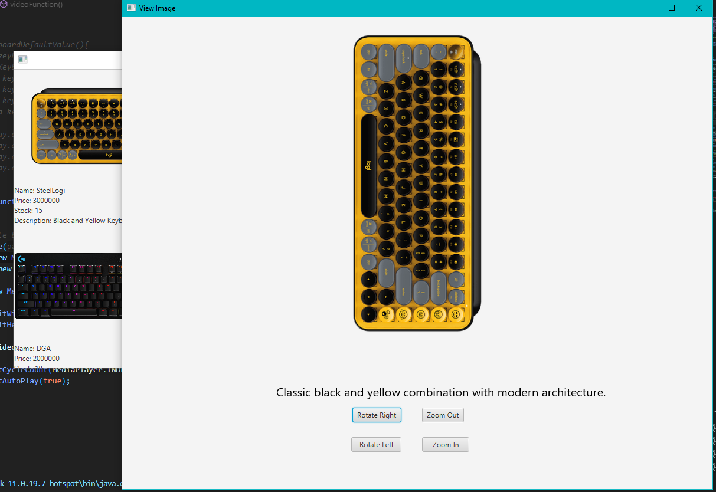
Figure 12. Item Detail Window
The application will display the View Image Window when users clicked keyboard image button from Manage Keyboard Window. The list of components are listed below:
- Button for rotate left button, rotate right button, zoom in button, zoom out button.
- ImageView to show image.
- Text to show description.
The description for this window are listed below:
- Display the image of the keyboard depends on what image clicked from Manage Keyboard Window.
- Display the keyboard description based on the keyboard image that was clicked before.
- If the user clicks the rotate left button, the image will be rotated left to -90 degrees.
- If the user clicks the rotate right button, the image will be rotated right to 90 degrees.
- If the user clicks the zoom in button, the image will be zoomed in to 1.2 times larger from its last scale and validate image scale x does not exceed 2.5.
- If the user clicks the zoom out button, the image will be zoomed out to 0.8 times smaller than its last scale and validate image scale x does not less than 0.4.

Reference:
- https://gamesmea.com/wp-content/uploads/2021/11/K65_RGB_MINI_WHITE_WATERMELON_BLAST_12.png
- https://img.my-best.id/press_eye_catches/9a9d151cc0ee44a6c3508204fc5be788.png?ixlib=rails-4.2.0&q=70&lossless=0&w=1400&h=787&fit=crop
- https://resource.logitechg.com/d_transparent.gif/content/dam/gaming/en/products/pro-x-keyboard/pro-x-keyboard-gallery-1.png
- https://img.my-best.id/press_eye_catches/3f9e30c9efbea95b89fe1e26a5e83ee4.png?ixlib=rails-4.2.0&q=70&lossless=0&w=1400&h=787&fit=crop
- https://www.youtube.com/watch?v=iIRKiWa7_bQ
- https://www.chosic.com/download-audio/28546/

